dirSysprep :

* na to, aby sme zmenili ID serveru



* premiestni nás do windiru (bez toho aby to muselo dajak hladat)

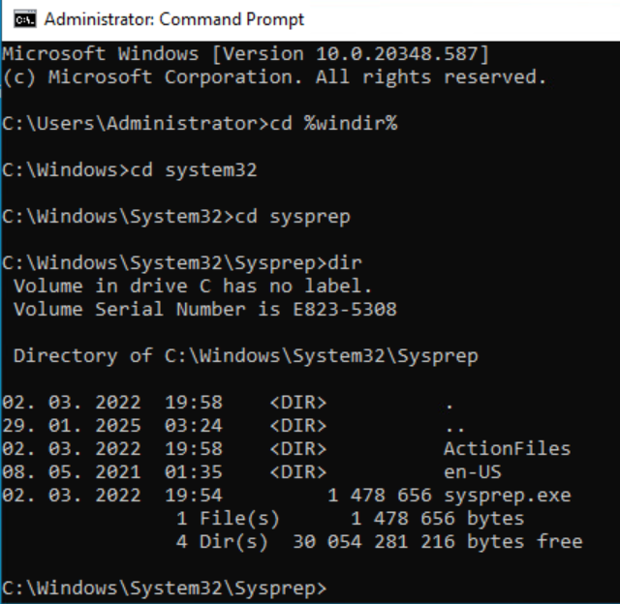

* presun do sysprep

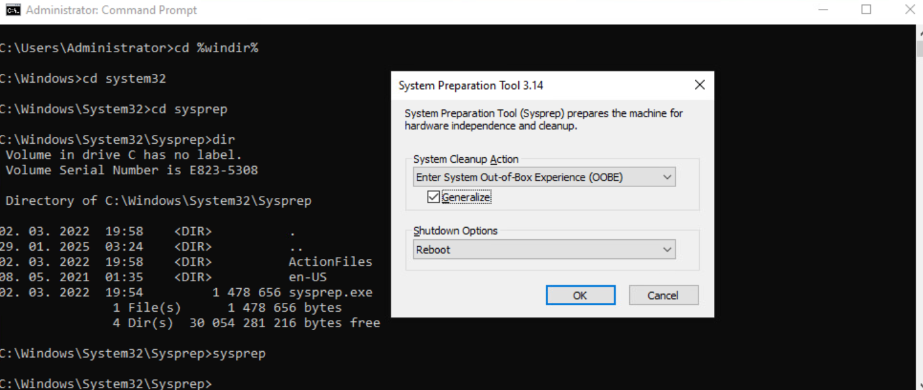

* pripravenie sysprepu

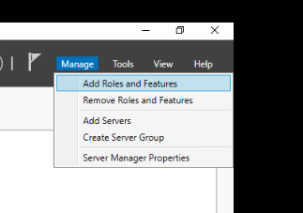

NEXT

NEXT

NEXT

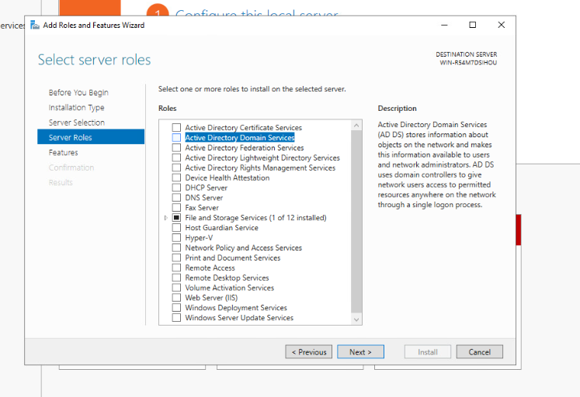

ADD FEATURE

NEXT

NEXT

NEXT

INSTALL

* ked vsetko urobis, zapnes server a toto svieti, tam kliknes na promote this server ...

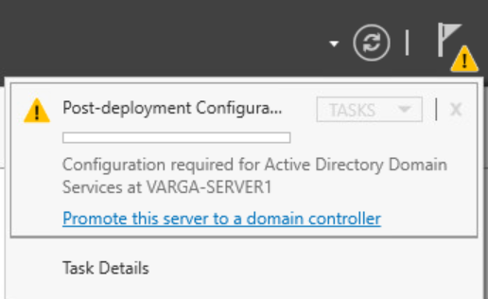

* nemas forest takze vytvoris

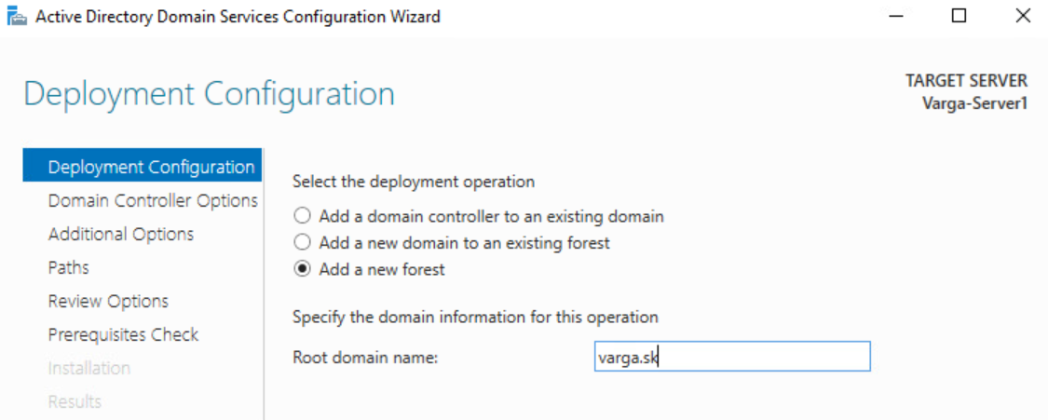

* tu si vyberies levle

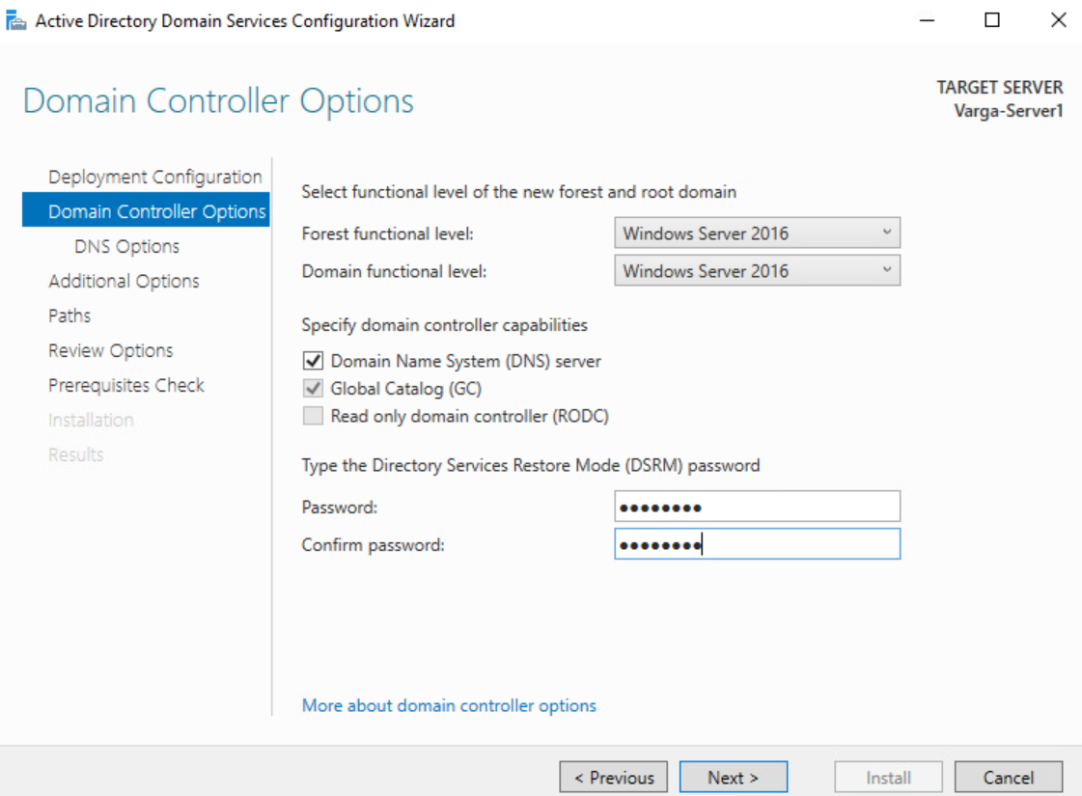

* DNS delegation nedavas
* NetBIOS Domain name nechas tak (je to kvoli kompatibilite so starsimi zariadeniami)

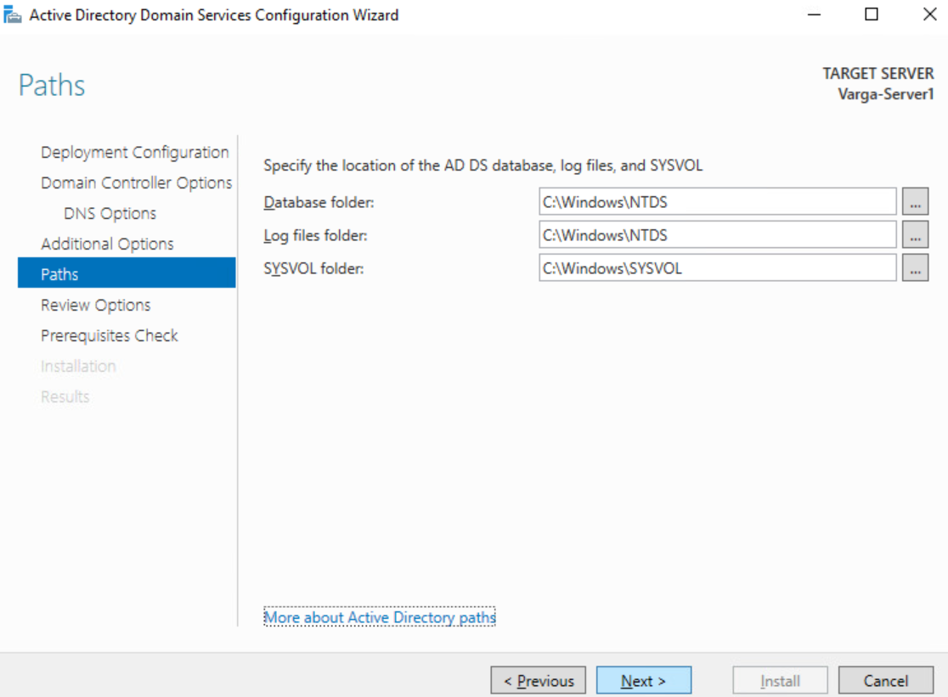

* kvoli rychlosti sa odporuca dat na iny disk, nie systemovy ale to nic, nechame tak
* potom len next

2HY SERVER

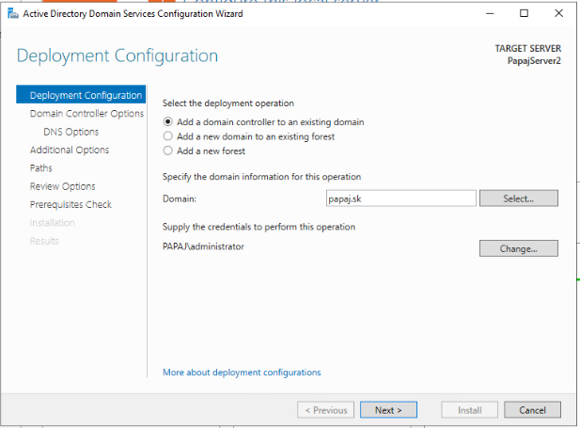

NEXT

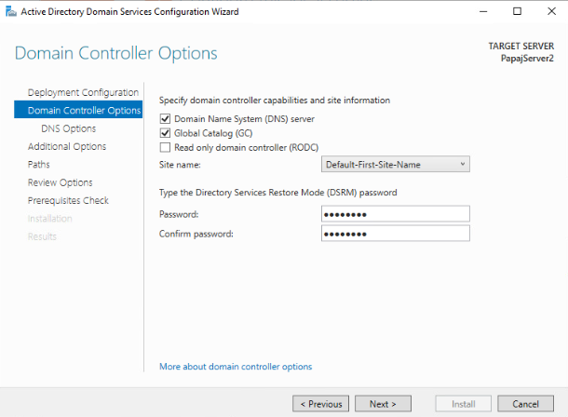

NEXT

NEXT

PRIDAME REPLICATE FROM

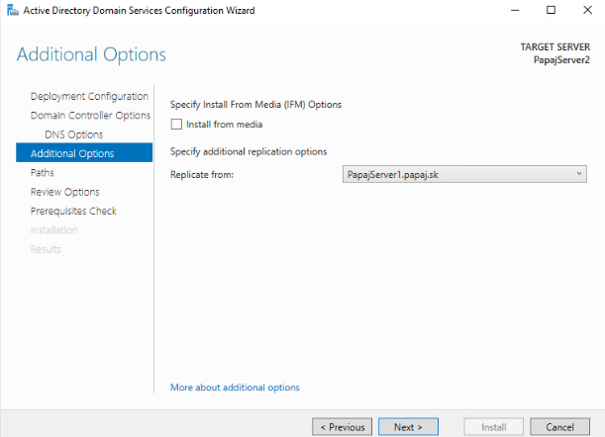

NEXT

NEXT AZ PO INSTALL